

Want to know what it’s like to work with us? Here’s Laura Quick (Nee cooper) who graduated from Northampton in 2020 and joined us fresh out of uni…..

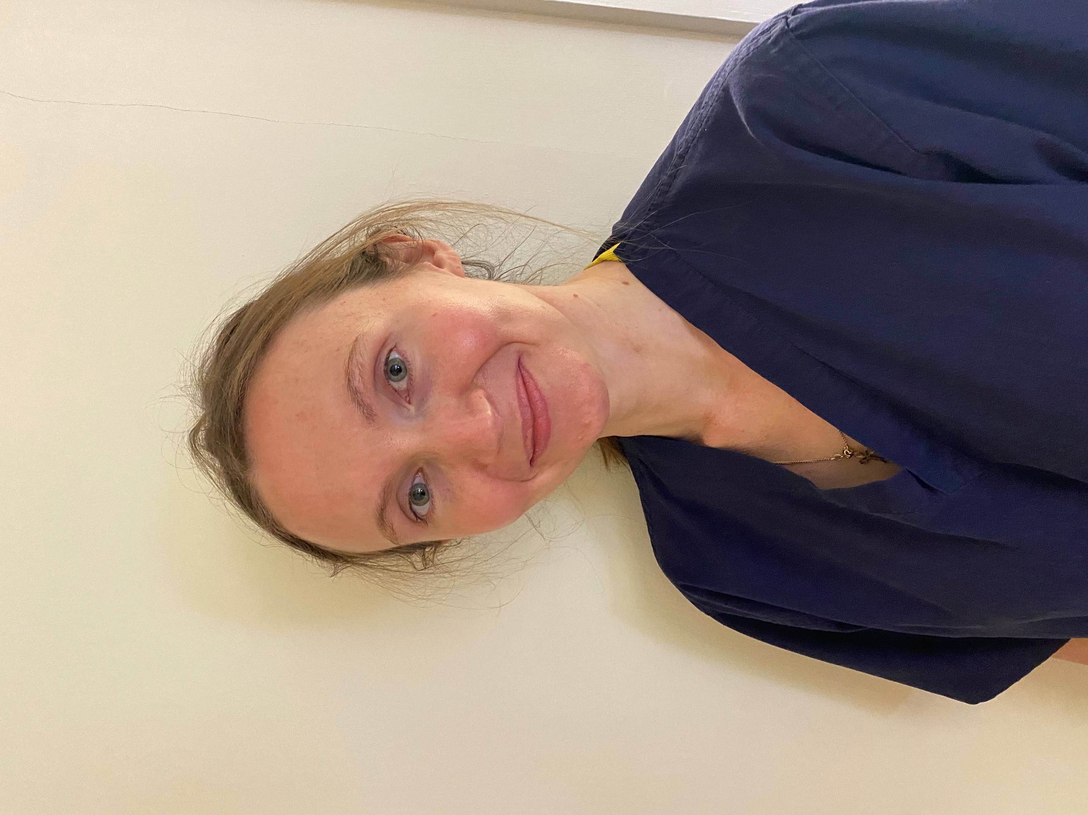
“After graduating in 2020 I started my career in private practice working for Head and Short Podiatry. I have heard many times different people saying to me you hit the ground running if you enter private practice, however with Head and short this was simply not true. The amount of help and support I have received has been paramount to my success and the development of my career so far. From the start I was provided with one-to-one mentoring, encouragement, and educational opportunities that some of my peers have not received.

Kelsey and Julian go the extra mile to support new graduates and develop them into capable practitioners with ongoing professional development but also by focusing on your strengths, positive self-talk, and praise to enhance your professional abilities.

Head and Short have also provided me with a structured further education program, which is quite unique to find in private practice and have invested in me to further my career. So far, I’ve attended and completed the Royal College of Podiatry new graduate MSK module, many mandatory training courses (including basic life support, moving and handling, POMs update, IT training, etc.) and this summer I’m attending the weeklong Lower Limb at Risk course at Northampton – all fully funded! We also get the opportunity to attend the college of podiatry conference each year!

I am now a very capable practitioner and have the professional confidence which I did not have when I started, this is thanks to the mentoring from Julian Head and Kelsey Short. I feel transformed from a newly qualified graduate to a fully confident and able podiatrist, who can go the extra mile and make a difference to our patients lives.

Asides from that ii is a fun and happy atmosphere to work in, great people and an experience I am extremely glad I took.”

Laura x

How to apply:

Please go to our jobsite: www.headandshort.co.uk/jobsite, you will find more information and full details on how to apply there

