
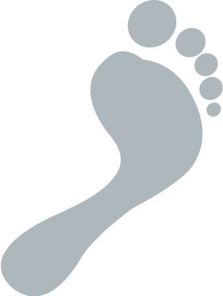

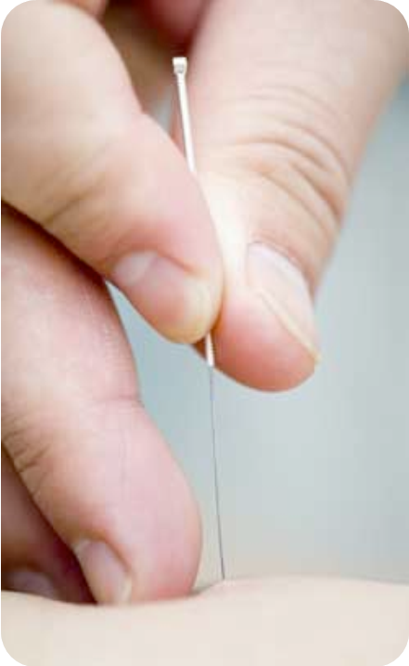
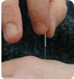
Either locally, to the affected area, or further away where traditionalists believe the Meridian pathways exist, or simply around a lesion. Specific points exist on the body, such as hands and ears, which have been shown to aid the overall well being of the patient.
Because Podiatric acupuncture is administered to the limbs, side effects are very rare. Occasionally some patients experience a small amount of bleeding from the needle site. Bruising can occur the following day but usually clears after a few days.
Commonly treated conditions are myofascial trigger-points, neuromas, tendinosis, plantar fasciitis, sprains, over-use injuries, arthritis, ulcers and verrucae.
Acupuncture needles are sterile disposable needles, with a fine diameter, of varying lengths.

Please telephone us to make an appointment:

Harpenden 01582 467667
Hertford 01992 505105
St. Albans 01727 865343
Stoke Newington 0207 275 0382

www.headandshort.co.uk/podiatry
Head & Short Podiatrists Ltd, 14 High Street
Harpenden="" "[City]" HarpendenHarpenden \* MERGEFORMATSt. Albans, Herts="" "[State]" HertsHerts \* MERGEFORMATHerts. AL5 4DB="" "[Postal Code]" AL5 4DBAL5 4DB \* MERGEFORMATAL3 4EL
Company reg. 6741445 VAT No. 975 7625 65
Head Office:
All our Podiatrists (Chiropodists) are educated to degree standard (or equivalent), are registered with the Health & Care Professions Council and are full members of the College of Podiatrists
What can be treated?
What are the needles like?
Integer egestas orci quis lorem feugiat adipiscing.
Where are they applied?
Can Podiatric acupuncture make me worse?
Podiatric Acupuncture

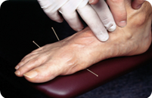
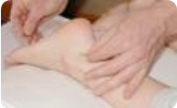
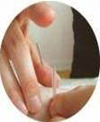
Scientists are unsure about how some aspects of acupuncture work. Some research has shown that acupuncture stimulates the release of endorphins in the brain, which are natural chemicals, which block pain (analgesia). Other studies have shown Neuro-chemicals, both from the central nervous system and from the skin and muscle, are released. These are thought to have a role in healing. However, further research is required on the effects of acupuncture in respect of specific disorders.
Yes, if they have completed a course recognised by the Society of Chiropodists & Podiatrists. Courses have been running for over 10 years and training is provided by Medical Doctors, Acupuncturists and experienced Podiatrists.
It is a form of therapy used to treat Podiatry disorders and Podiatry-related conditions.
Acupuncture is a form of Chinese Medicine (TCM), which has been used for many centuries to cure infection and disease, reduce pain and improve the psychological well being of the individual. Traditional Practitioners say this is done by rebalancing the patient’s Yin and Yang, through unblocking their Qi (vital energy), which brings harmony to the body.
In TCM, disease is the result of losing balance between Yin and Yang; pain is an indication of blockage of the flow of Qi, blood and other fluids.
Treatment can comprise of needles or the application of warmth to specific points on meridians (energy pathways) or tender points (known as ‘ah shi’)
Treatment can comprise
What happens at the appointment?
Following a thorough consultation and diagnosis the Podiatrist will discuss the suitability of acupuncture for your problem. Needles may be applied to the area of pain, close by or even on your hand or ear. The needles are inserted according to need, usually a few millimeters into the skin or into muscle. Patients usually experience no pain, but possibly a twinge or tingling moment then relief. In TCM this is called “dechi”. The needles are left for a few minutes and may be stimulated by light tapping or gentle twisting.
The total number and frequency of visits depends on your problem and how severe it is. For instance, a neuroma may take only 2 treatments whilst verrucae may take many more.
Treatment is suitable for all ages. There is no official record of any adverse side effects with Podiatric acupuncture.
How often do I need to attend?

The traditional view of acupuncture
The scientific community has questioned TCM theory, for there is no verifiable basis for meridians or acupuncture points. However, recent research has thrown new light on the role of acupuncture in pain relief, both acute and chronic, and other problems such as myofascial symptoms, trigger points, nausea, drug addiction and headaches.

The scientific view
How does acupuncture work?
Who can have it?
Can Podiatrists do acupuncture?
What is Podiatric Acupuncture?

